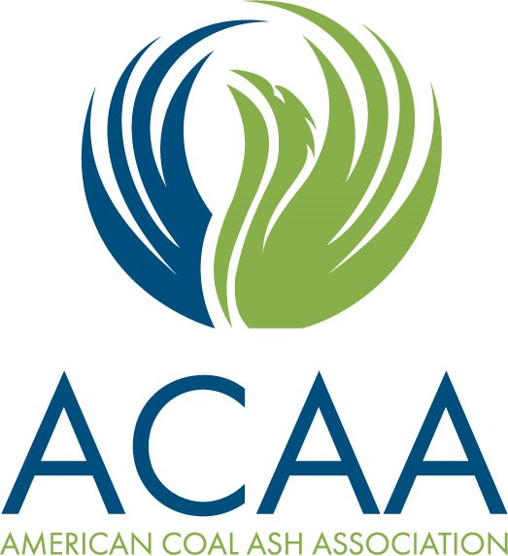

Sponsor and Exhibitor Remittance Form

Primary Sponsor or Exhibitor Contact Information *complimentary registration information, if applicable*
Name_______________________________________________________________ Mr. Mrs. Ms. Miss Dr.
Organization _______________________________________________________________________________________
Street Address ______________________________________________________________________________________
City __________________________________ State/Province _________________ Postal Code ____________________
Country ____________________________ Email __________________________________________________________
Phone (______)____________________ Fax (______)_____________________ Mobile (_______)__________________

Sponsorship and Exhibit Opportunities – Please check all that apply.
Note: sponsorship items, i.e. lanyards, pens, etc. are to be produced and delivered by the sponsor directly to the venue.
Individual item sponsorship = $650 + cost of item & shipping.

_____Tabletop Exhibit Opportunity $2,000
_____ Platinum Sponsor $5,000 _____ Lanyards (minimum: $650)
_____ Diamond Sponsor $1,500 _____ Pens (minimum: $650)
_____ Gold Sponsor $1,000 _____ Notepads (minimum: $650) _____ Silver Sponsor $750 _____ Logo Hotel Keys (minimum: $850)
_____ Bronze $500 _____ Other___________________

We are open to other suggestions as well! Contact Chandice Marchio to discuss your own custom sponsorship package!

Sponsored items are given on a first come, first served basis and all sponsorships at the dollar amounts shown are considered co-sponsorships and are not exclusive.

Payment Information
Total Sponsorship Commitment: $_________ (US Dollars) Total Exhibit Commitment: $ _________(US Dollars)

Check made payable to ACAA
Visa MasterCard American Express Discover

Card Number: _____________________________________ Exp. Date ____________CSC________(3 digit security code)
Card Holder’s Name _________________________________________________________________________________
Card Holder’s Address _______________________________________________________________________________

Signature __________________________________________________________ Date ___________________________

Please send completed form to:
Chandice Marchio – Chandice.marchio@acaa-usa.org
38800 Country Club Drive
Farmington Hills, MI 48331

