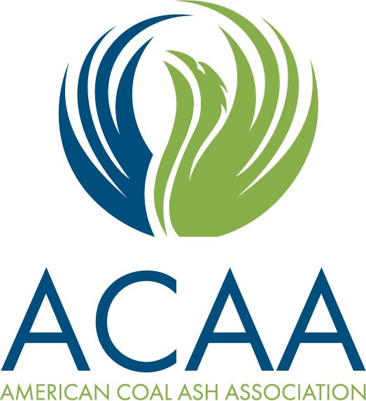

2020 CCP Ponded Ash, Harvesting and
Beneficiation Workshop

Sponsor and Exhibit Opportunity
June 23rd & 24th, 2020
Renaissance Birmingham Ross Bridge Golf Resort & Spa – Birmingham, AL

Receive additional exposure by participating in one of the following sponsorship opportunities. Please note the sponsor opportunities are non-exclusive and item sponsors are on a first come basis.

Display Opportunity at the $2,000 level: We will have exhibit tables to display promotional materials or samples. A complimentary event registration for one attendee/exhibitor will also be included. Please Note: the display tables will be in a public area and neither ACAA, UK CAER, EPRI, nor the hotel will be responsible for their security at any time.
PLATINUM SPONSORSHIP $5,000.00
What you get: As a Platinum Co-sponsor, your company will be recognized during the Workshop, receive online exposure, logo will appear on the agenda and on signage throughout the events. You will also receive a one-page ad in the Workshop program book and a customized promotional opportunity to be discussed with Chandice Marchio. Also, your company will receive a complimentary display table with event registration for two attendees.
DIAMOND SPONSORSHIP $1,500.00
What you get: As a Diamond Co-sponsor, your company’s logo will appear on signage at the Welcome Reception, receive online exposure, on the agenda and option to receive a one-page ad in the Workshop program book. If you chose, you can also bring a promotional item to be handed out during the welcome reception.

GOLD SPONSORSHIP $1,000.00
What you get: As a Gold Co-sponsor, your company’s logo will appear on signage at the luncheon, receive online exposure, on the agenda, and option to receive a half-page ad in the Workshop program book.
SILVER SPONSORSHIP $750.00
What you get: As a Silver Co-sponsor, your company’s logo will appear on signage at the breakfast, receive online exposure, on the agenda, and option to receive a half-page ad in the Workshop program book.
BRONZE SPONSORSHIP $500.00
What you get: As a Bronze Co-sponsor, your company’s logo will appear on signage at the break and receive online exposure.
CUSTOMIZE SPONSORSHIP PACKAGES
If you are interested in a customized sponsor package or if you would like to sponsor specific items, for example: lanyards, notepads, or pens please contact Chandice Marchio by phone 248-848-3817 or e-mail Chandice.marchio@acaa-usa.org

